Gospel Reading Activities

Visio Divina

The practice of praying with visual images is called visio divina or divine seeing. It is adapted from the sixth-century Benedictine practice of Bible reading called lectio divina, using both the text and art to help the reader encounter the living Word of God. The rhythm of visio divina ignites the senses to “hear and see” the Word of God as one listens, meditates, and prays with the sacred text. Studying a text of Scripture and the illustration involves uncovering layers of meaning. When we have discovered the “voice” of the text, we can bring its images and lessons into the present and discern its significance for our life situations.

- Read: Read the following Scripture passage from the Gospel of Mark. Listen with the “ear of you heart” for a word or short phrase that God has for you this day.
The kingdom of God is as if someone would scatter seed on the ground, and would sleep and rise night and day, and the seed would sprout and grow, he does not know how. The earth produces of itself, first the stalk, then the head, then the full grain in the head. But when the grain is ripe, at once he goes in with his sickle, because the harvest has come. (Mark 4:26-29)
- Meditate: What does the word or phrase you have chosen mean to you today?
- See: Look at the image and let your eyes stay with the very first thing that you see. Keep your attention on that one part of the image that first catches your eye.

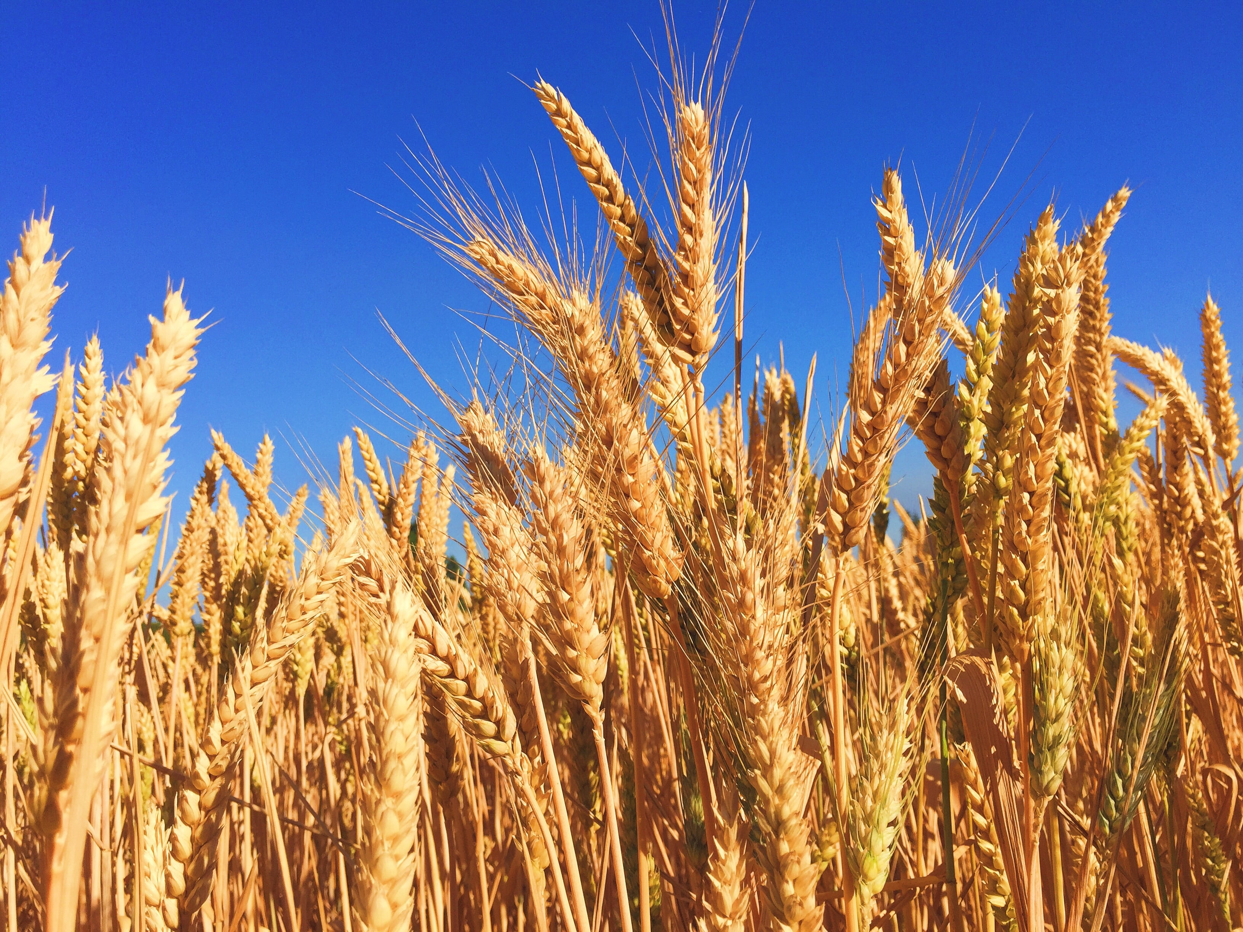
Photo by Melissa Askew on Unsplash

- Contemplate: Breathe deeply and let yourself gaze at that part of the image for a minute or so. Now, let your eyes gaze at the whole image. Take your time and look at every part of it. See it all. Reflect on the image for a minute or so.
- Reflect: What emotions does this image evoke in you? What does the image stir up in you, bring forth in you?
- Pray: What do you want to pray for today?

