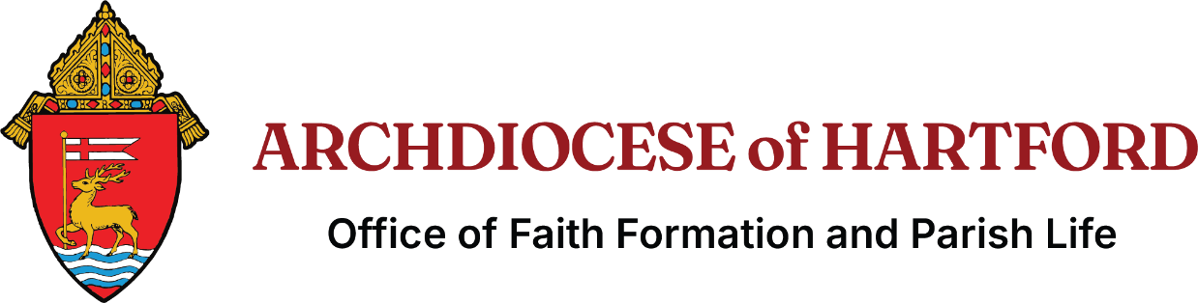

Thank you for your registration.
Please print out, sign and return to:
Office of Faith Formation and Parish Life
467 Bloomfield Avenue
Bloomfield, CT 06002.
Or by email to Jennifer.McClintock@aohct.org

Candidates’ Names:

Catechist Endorsement
By signing this form, I testify that the applicant has completed their catechesis, has resolved all sacramental obstacles, and is prepared to receive the sacrament of Confirmation. I am attaching herein all sacramental records for this confirmand. It is the responsibility of the catechist to collect all sacramental records, verify questions of sacraments and marriage, and provide copies as requested by the Office of Faith Formation and Parish Life.

Catechist’s Signature: ____________________________________________________________________

Date: _____________________

Pastor of Registered Parish Endorsement
By signing this form, I am testifying that the information for this candidate is correct and that this candidate is prepared for the sacrament of Confirmation with no marriage impediments.

Pastor’s Signature: _________________________________________________________________________

Date: _____________________

